**The University of New Mexico**

**School of Engineering**

**Electrical and Computer Engineering Department**

**ECE 535 Satellite Communications**

**Student Name: Scott Nguyen**

Module # 3: Problems 2.12, 2.13, 2.14, 2.16, 2.17,2.18

Summer 2025

**Prof. Tarief Elshafiey**

2.12: Explain what is meant by the ascending and descending nodes. In what units would these be measured, and in general, would you expect them to change with time?

* The ascending node is where an orbiting object crosses the reference plane going from south to north, while the descending node is where it crosses going from north to south. These nodes are measured as angles in degrees or radians from a fixed reference direction. Because of factors like Earth’s shape and gravitational forces, the positions of these nodes slowly change over time.

2.13: Explain what is meant by (a) line of apsides and (b) line of nodes. Is it possible for these two lines to be coincident?

* The line of apsides connects the periapsis and apoapsis, defining the longest axis of the orbit. The line of nodes is where the orbit crosses the reference plane, linking the ascending and descending nodes. These lines can be the same only if the orbit lies exactly in the reference plane, which occurs when the inclination is zero. Otherwise, they are usually different.

2.14: With the aid of a neat sketch, explain what is meant by each of the angles: inclination; argument of perigee; right ascension of the ascending node. Which of these angles would you expect, in general, to change with time?

* Inclination is the tilt angle between the orbit plane and the Earth’s equator. Right ascension of the ascending node (RAAN) is the angle measured along the equator from a fixed reference direction to where the orbit crosses northward. The argument of perigee is the angle in the orbit plane from the ascending node to the closest point in the orbit. RAAN and argument of perigee usually change over time due to gravitational effects, while inclination stays mostly constant.

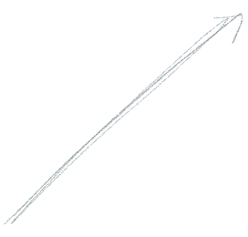

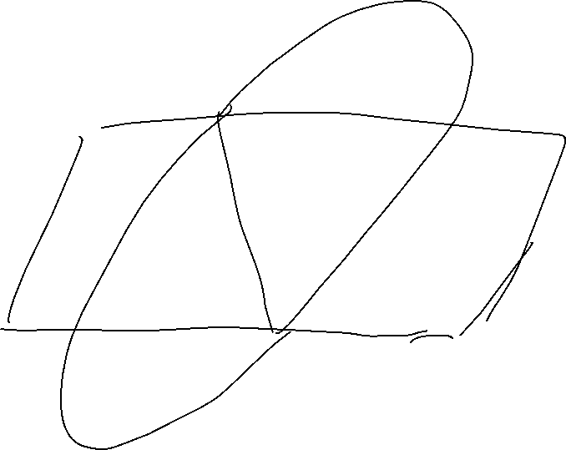

2.16: Describe briefly the main effects of the earth’s equatorial bulge on a satellite orbit. Given that a satellite is in a circular equatorial orbit for which the semimajor axis is equal to 42,165 km, calculate (a) the mean motion, (b) the rate of regression of the nodes, and (c) the rate of rotation of argument of perigee.

Earth’s equatorial bulge causes gravitational effects that make the orbit’s nodes slowly move the orbit’s closest point rotate.

Given:

* a = 42165 km
* i = 0 deg
* mu = 3.986e5 km^3/s^2
* Re = 6378 km
* J2 = 1.08263e-3

a). Mean motion n

* n = sqrt(mu / a^3)
* n = sqrt(3.986e5 / 42165^3)
* n = 7.3e-5 rad/s

b). Rate of nodal regression dW/dt

* dW/dt = -1.5 * J2 * (Re / a)^2 * n * cos(i)
* dW/dt = -1.5 * 1.08263e-3 * (6378 / 42165)^2 * 7.3e-5 * cos(0)
* dW/dt = -2.7e-9 rad/s

c). Rate of argument of perigee rotation dw/dt

* dw/dt = 0.75 * J2 * (Re / a)^2 * n * (5 * cos(i)^2 - 1)
* dw/dt = 0.75 * 1.08263e-3 * (6378 / 42165)^2 * 7.3e-5 * (5 * cos(0)^2 - 1)
* dw/dt = 5.4e-9 rad/s

2.17: A satellite in polar orbit has a perigee height of 600 km and an apogee height of 1200 km. Calculate (a) the mean motion, (b) the rate of regression of the nodes, and (c) the rate of rotation of the line of apsides. The mean radius of the earth may be assumed equal to 6371 km.

Given:

* r_p = 600 + 6371 = 6971 km
* r_a = 1200 + 6371 = 7571 km
* a = (6971 + 7571) / 2 = 7271 km
* e = (7571 - 6971) / (7571 + 6971) = 600 / 14542 ≈ 0.041

a).

* n = sqrt(3.986e5 / 7271^3) = sqrt(3.986e5 / 3.84e11) = sqrt(1.038e-6) = 0.00102 rad/s

b).

* dW/dt = -1.5 * 1.08263e-3 * (6371 / 7271)^2 * 0.00102 * cos(90°) / (1 - 0.041^2)^2
* dW/dt = -1.5 * 1.08263e-3 * 0.768^2 * 0.00102 * 0 / 0.9966
* dW/dt = 0 rad/s

c).

* dw/dt = 0.75 * 1.08263e-3 * (6371 / 7271)^2 * 0.00102 * (5 * cos(90°)^2 - 1) / (1 - 0.041^2)^2
* dw/dt = 0.75 * 1.08263e-3 * 0.768^2 * 0.00102 * (5 * 0 - 1) / 0.9966
* dw/dt = 0.75 * 1.08263e-3 * 0.59 * 0.00102 * (-1) / 0.9966
* dw/dt = -4.9e-7 rad/s

2.18: What is the fundamental unit of universal coordinated time? Express the following times in (a) days and (b) degrees: 0 h, 5 min, 24 s; 6 h, 35 min, 20 s; your present time.

* The fundamental unit of UTC is the second.

a. Days

* 0 h, 5 min, 24 s
  + 5*60 + 24 = 324 s
  + 324 / 86400 = 0.00375 days
* 6 h, 35 min, 20 s
  + 6 × 3600 + 35 × 60 + 20 = 23720 s
  + 23720 / 86400 ≈ 0.27454 days
* 22 h (current UTC time)  
  • 22 × 3600 = 79200 s  
  • 79200 / 86400 = 0.91667 days

b). Degrees

* 0 h, 5 min, 24 s
  + 324 / 240 = 1.35 deg
* 6 h, 35 min, 20 s
  + 23720 / 240 = 98.83 deg
* 22 h
  + 79200 / 240 = 330 deg